**ARchitecture User Manual v1.0**

Lam Pham

An Nguyen

**Table of Contents**

**I. Overview:** 3

**II. Purpose:** 3

**III. Summary:** 3

**IV****. Basic System Requirements:** 3

**V****. Core Functionalities:** 4

**VI. Setting:**5

**VII. Add Model:**6

**VIII. Model Selection:**6

**IXI. Model Selection:** 7

# **I. Overview:**

ARchitecture utilizes augmented reality technology to display a 3D computer-generated model into reality through the mobile device’s camera. ARchitecture utilized one of the most popular augmented development platform developed by Apple. ARchitecture is potentially capable of detecting a horizontal plane, placing 3D architectural models into reality, interacting with the models that have been placed, and detecting physical images.

**II. Purpose:**

As meeting and knowing different people work in architecture field, we recognize there are some inconvenient steps during the process of finalizing the structure model with customer before executing the plan. Architects are required to construct models either using 3D sketch software or real physical models upon the ideas and desire of customers. The process consumes times and resources such that the project is also under time constraint. We thought that create an application that allows users to view and interact with their models on a mobile device’s screen themselves.

**III. Summary**

Upon the running the application, it will automatically enables camera with various functionalities on the camera view that users can set and interact. Users can have the ability to choose and have a full view of the certain model.

**IV. Basic System Requirements:**

Here is a list of recommended iOS devices with software version in order to get the most out of ARchitecture.

Hardware:

* *iPhone Devices*: iPhone 8, iPhone 8 Plus, iPhone X, iPhone 7, Iphone 7 Plus, iPhone 6s, Iphone 6s Plus, iPhone SE, iPhone 6.
* *iPad Devices:* iPad Pro (12.9-inch), iPad Pro (9.7-inch), iPad Pro 12.9-inch (2nd generation), iPad (5th generation).

*Note:* The ideal iOS device for the application is the latest iPhone model which is iPhone X because it offers better capabilities.

Software:

* iOS devices is running on version 11.3+

Due to Apple high fee in Apple Developer Program to be to publish the application to

App Store. Since the app itself is not publicly available, below screenshots showing how the application looks like while executing. In case users want to take a glimpse of the project structure. Here is the link: <https://github.com/nguyenAn1201/ARchitecture>

# **V. Core Functionalities:**

The application consists 4 main functions: Reset, Model Selection, Display Model and Setting. Upon the app loaded, it enables the camera with various provided options to users.

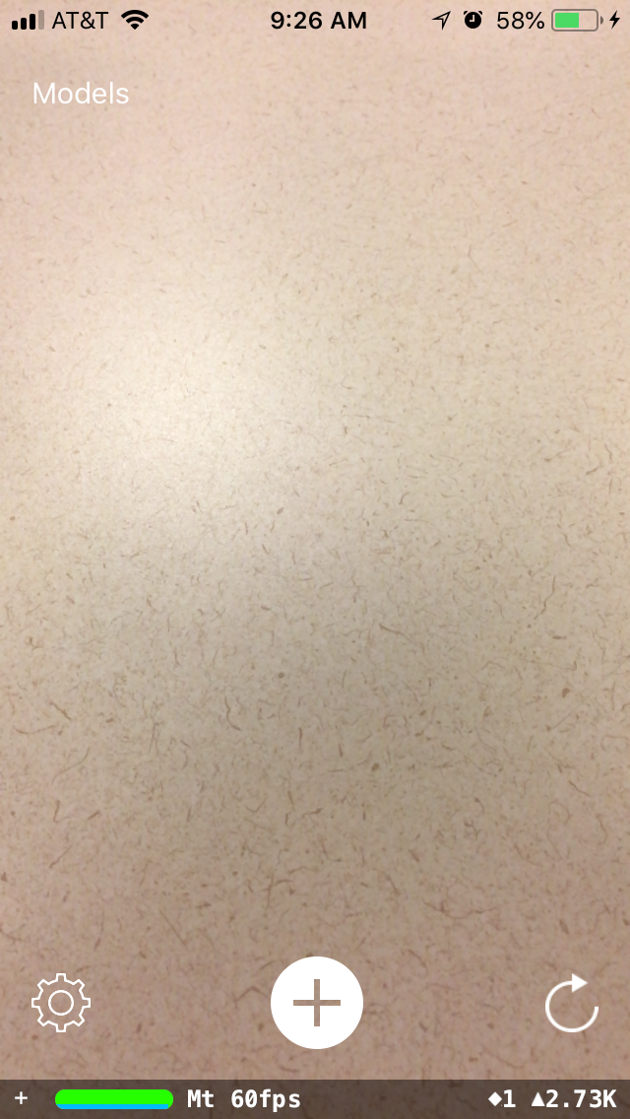

In Figure.1, the bottom left icon is the Setting option which enables different features for analyzing and evaluate a certain surfaces. The bottom right corner icon is Reset option which allows users to clear all previously displayed models and set a new session. The middle tapping icon is for putting a model onto the detected surface. The top left corner is a Models button that contains all available models for users to try.

**Figure 1. Overview UI of ARchitecture**

**VI. Setting**  
 As aforementioned in Section III, Setting option allows users to have different testing features before put a model into the screen. It basically tracks the status along with camera changes.

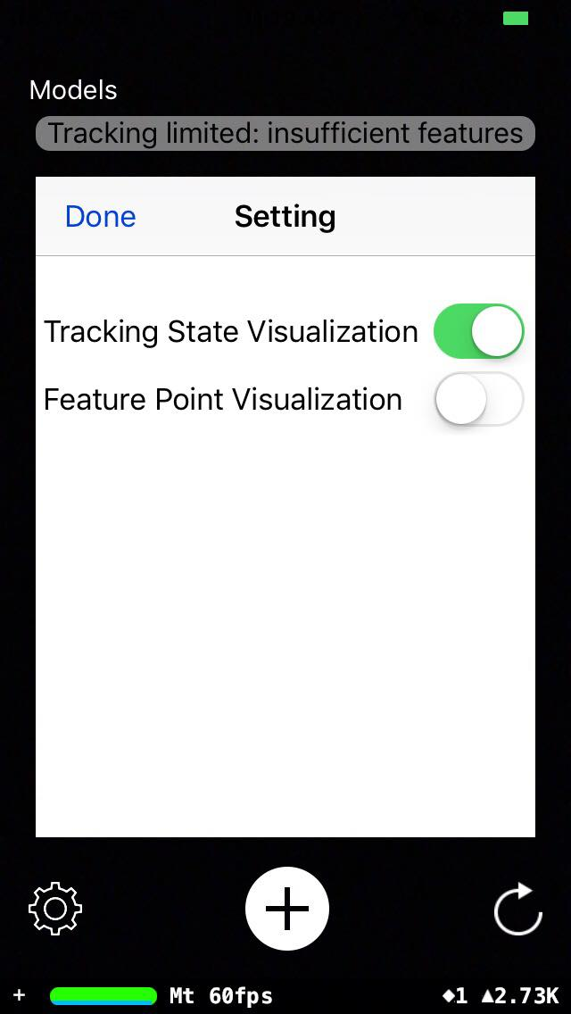

In Figure.2 shows the popup after Setting option is clicked. Tracking State options helps users to determine whether the displaying plane is sufficient enough. All factors are considered include brightness, plain surfaces. Other than that, Feature Point shows all feature yellow dots onto camera screen which represent all features detected.

**Figure 2. Popup Setting View**

**VII. Add Model**

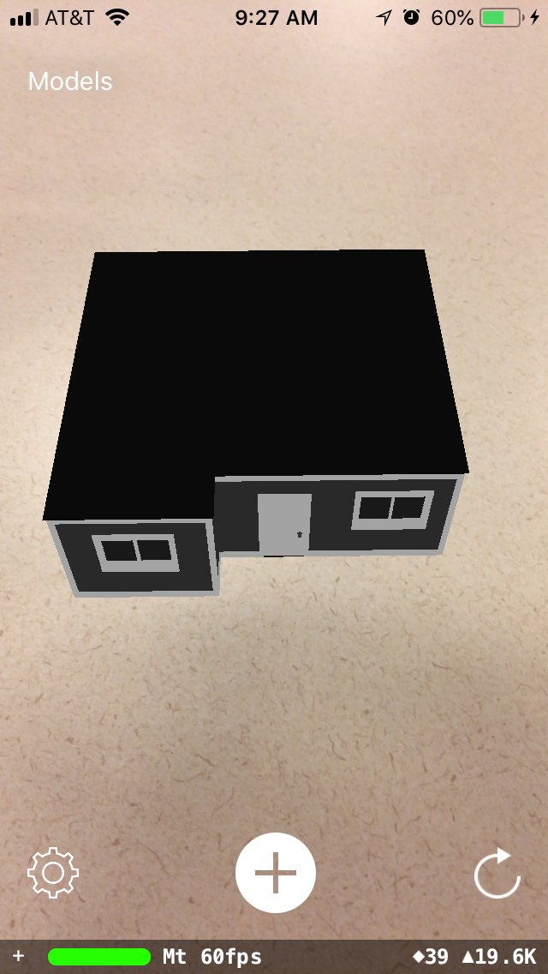

The main function of ARchitecture. It lets users to demonstrate a selected model onto the camera screen after analyze and evaluate the quality of detected plane. Users can directly interact with the model through scaling, zooming, rotating (Figure 3). It also supports multi-models display within a session. The house has ability to support users an inside tour.

**Figure 3. Displaying a model**

**VIII. Model Selection**

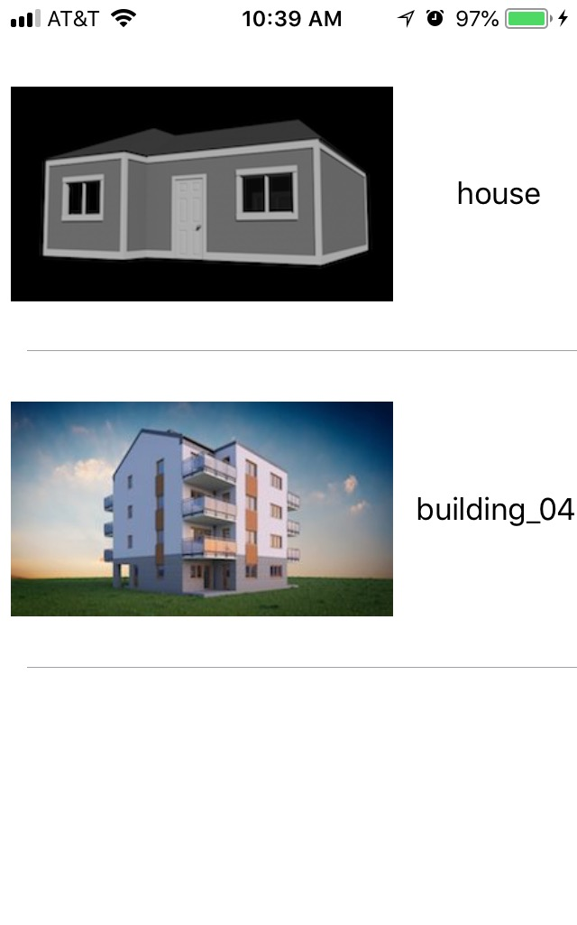

From the main screen, Model button on top left corner enables users the ability to change the displayed model. It will list out all available resources for users to select. For now, ARchitecture only provides a limited number of structures. After choosing a particular house, Add button exhibits it onto the device’s screen while keeping the previously loaded model. This function is essential because it also allows users to compare between houses so they can decide their own preference.

**Figure 4. Model Selection View**

**IX. Final Words**

The ARchitecture is potentially a success of applying augmented reality technology into mobile devices in architecture field. For now, ARchitecture achieves with most of initial goal. Unfortunately, the application is unavailable at the moment. With the growth of augmented reality in both iOS and Android, further advancement and deployment of the project will be carried on and developed in a near future.